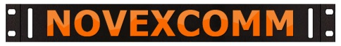MAGNETIC MIKE CONVERSION KITS
YOUR MIKE MAY VARY; THIS IS SHOWING THE ICOM HAND MIKE CONVERSION, BUT THEY ARE ALL SIMILAR
IT WILL LOOK LIKE THIS WHEN FINISHED, OPEN THE BACK AND DRILL A HOLE THROUGH THE PLASTIC CENTER
PUSH THE BOLT THROUGH AND TIGHTEN THE THREADED MIKE PAD ON SO IT LOOKS LIKE THIS
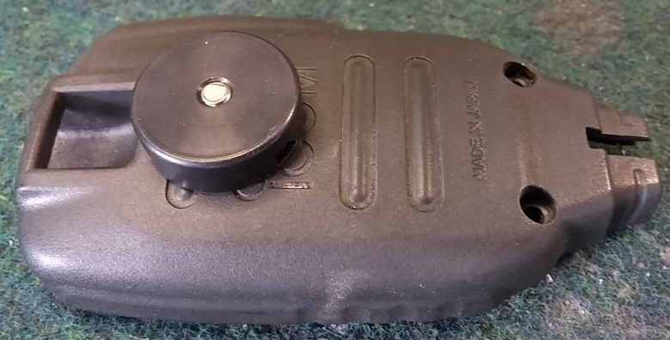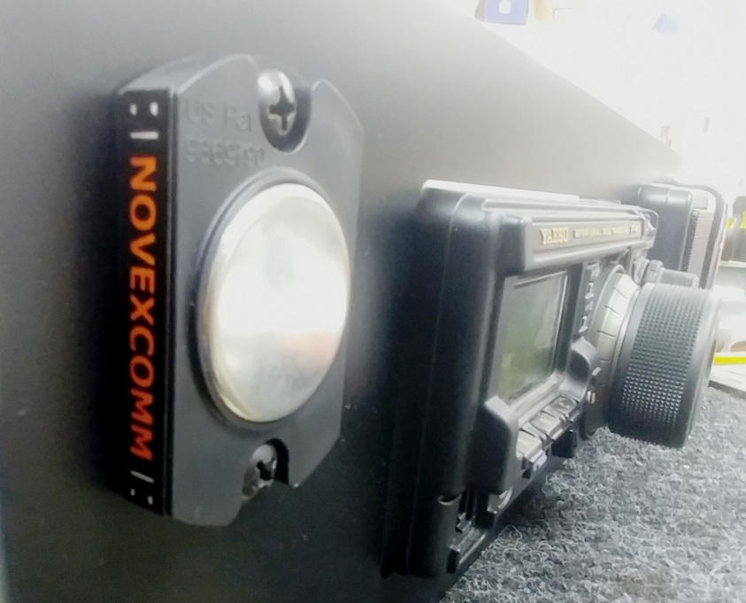
IF YOUR MAGNETIC BASE ISN’T ATTACHED TO YOUR PANEL THEN WHEN COMPLETED IT LOOKS LIKE THE IMAGE ABOVE
NOTES ABOUT OTHER MIKE CONVERSIONS:
- IF YOUR MIKE HAS ONE OF THE ALUMINUM OR PLASTIC COMMON STYLE CLIP-HANGERS FOR MIKE CLIPS SLIDE THE STEEL PAD ONTO THE HANGER AND JUST INSERT & TIGHTEN UP THE SET SCREW
- FOR KENWOOD, YAESU AND OTHERS WITH ‘HOOKS’ VS. CLIP-HANGER TYPES SOMETIMES YOU CAN USE THE FACTORY SCREW TO MOUNT THE MAG PAD; OTHER TIMES YOU OPEN THE MIKE AND DRILL THE CENTER PLASTIC
- WHEN USING THE BOLT FROM THE INSIDE BE SURE TO INSULATE THE HEAD FROM ANY ELECTRONICS
- IF NEED BE SAW OR GRIND OFF THE BOLT THREADED END TO NOT EXTEND PAST THE STEEL PAD FLAT SIDE
- IF YOUR MAG PAD BASE IS SHIPPED SEPARATELY THEN USE THE SUPPLIED SCREWS AND TEMPLATE TO DRILL
- THE BOLTS ARE 10/32 SIZE SO PLAN THE DRILL BIT ACCORDINGLY
- THEY MOUNT NICELY TO THE SIDES OF AN ABS MOLDED GO BOX AND LOOK GREAT ON A 2U STEEL DRAWER
- TO GET THE MIKE OFF THE PAD GRAB IT WITH YOUR FULL HAND AND ROLL YOUR WRIST SIDEWAYS…..EASY!
STILL GOT QUESTIONS? CALL US!
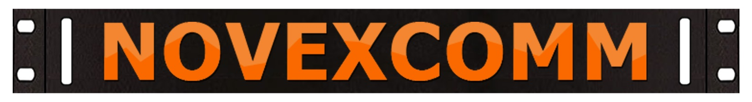
22826 MARIPOSA AVE. TORRANCE CA 90502 PHONE 310.534.4456 M-F 10 AM TO 6 PM PACIFIC (CALIFORNIA) TIME

